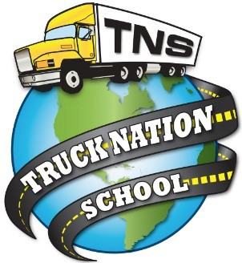TRUCK NATION SCHOOL
LOGO
2055 E. North Ave Fresno, Ca 93725 (559) 442-3696 WWW.TRUCKNATIONSCHOOL.COM

FRESNO ANNUAL REPORT

2019

Truck Nation School was approved by the BPPE on 7/11/19. As of 7/10/20 a year of data will be available for annual reports. Any questions a student may have regarding Truck Nation School that have not been satisfactorily answered by the institution may be directed to:

Bureau for Private Postsecondary Education
2535 Capitol Oaks Drive, Suite 400, Sacramento, CA 95833, P.O. Box 980818, West Sacramento, CA 95798-0818.

The telephone numbers are (888)370-7589 or (916) 431-6959.
If you prefer to reach them by fax you can do so at (916) 263-1897

